**CS 557**

**Delyar Tabatabai**

**Project 4 - Cube Mapping**

* What you did and explaining why it worked this way
  + As we did in project 3, we have the same displacement mapping here as well. But we have added cube mapping. We have 6 images of kelley department and we form them as a cube. When we zoom in, it feels like we are inside the cube. On the other hand, The vertex shader code calculates the displacement of a surface in the z direction based on the x and y positions of the vertex. The displacement is controlled by two uniform variables: uK and uP.
  + In order to create reflection, we trace the light from eye to the surface and reflect it to the pixel in cube. Whatever the color is, we color the pixel on the surface as that color. The surface is defined by its normal vector vNs and the vector from the eye position to the point vEs. The shader first rotates the normal vector using a noise function to simulate surface roughness. It then calculates the reflection and refraction vectors using the reflect and refract functions in OpenGL, respectively. The reflection and refraction colors are obtained from two separate cube maps specified by the uniform variables uReflectUnit and uRefractUnit, respectively. Finally, the two colors are mixed together using the mix function and output as the fragment color.
* A link to your video
  + <https://media.oregonstate.edu/media/t/1_wbdaex1l>

**Reflection:**

**k=0.01**

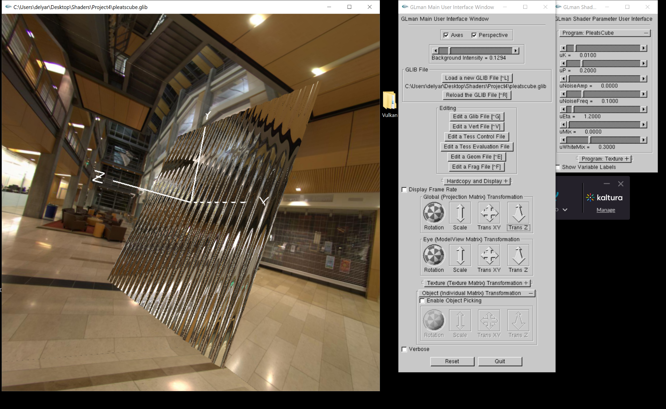

**K = 0**

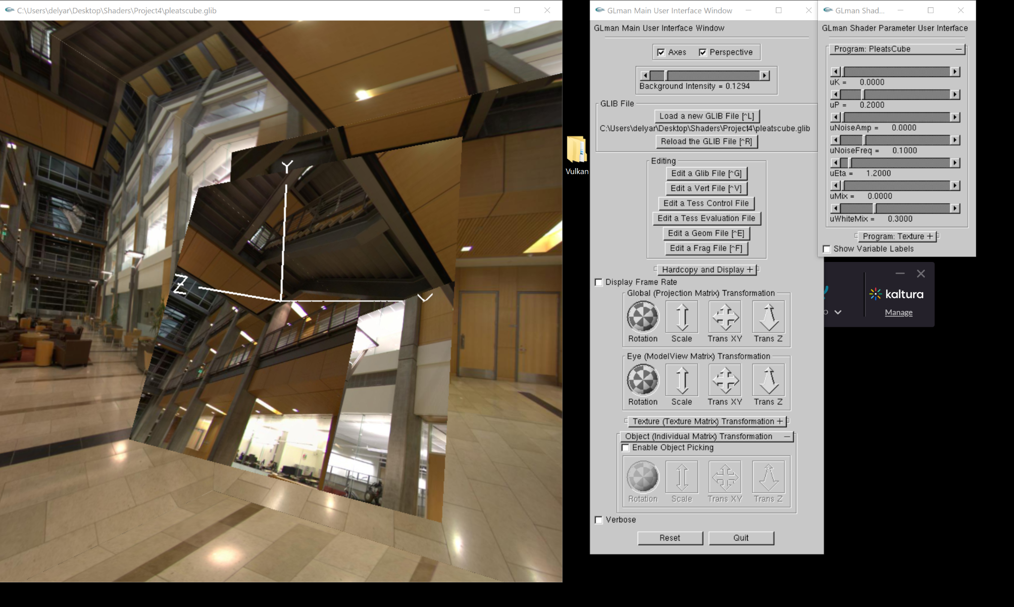

**p=0.053**

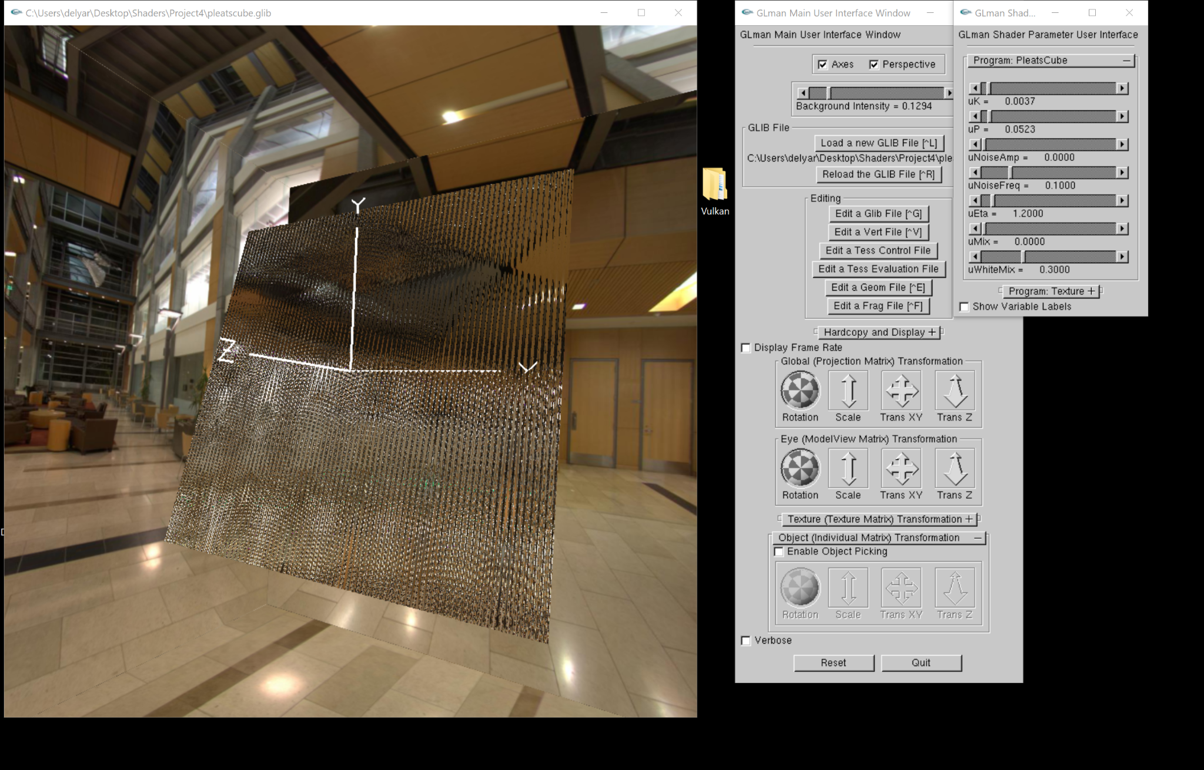

**p=0.77**

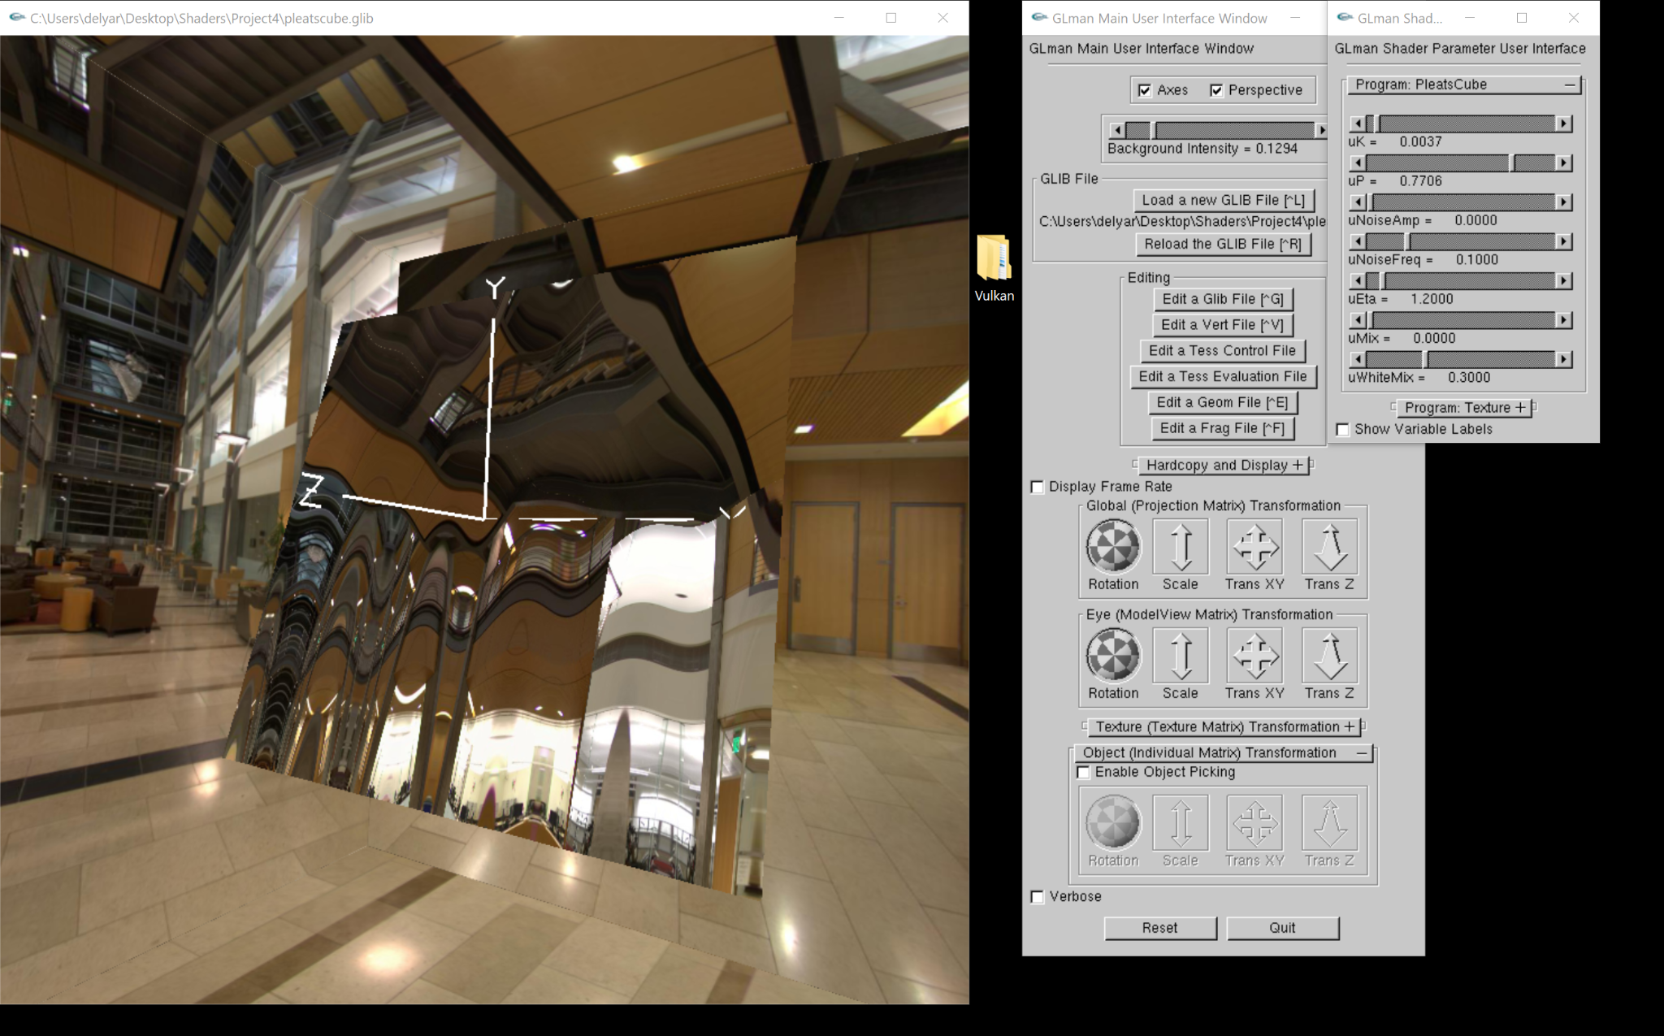

**Nois amp = 0.27**

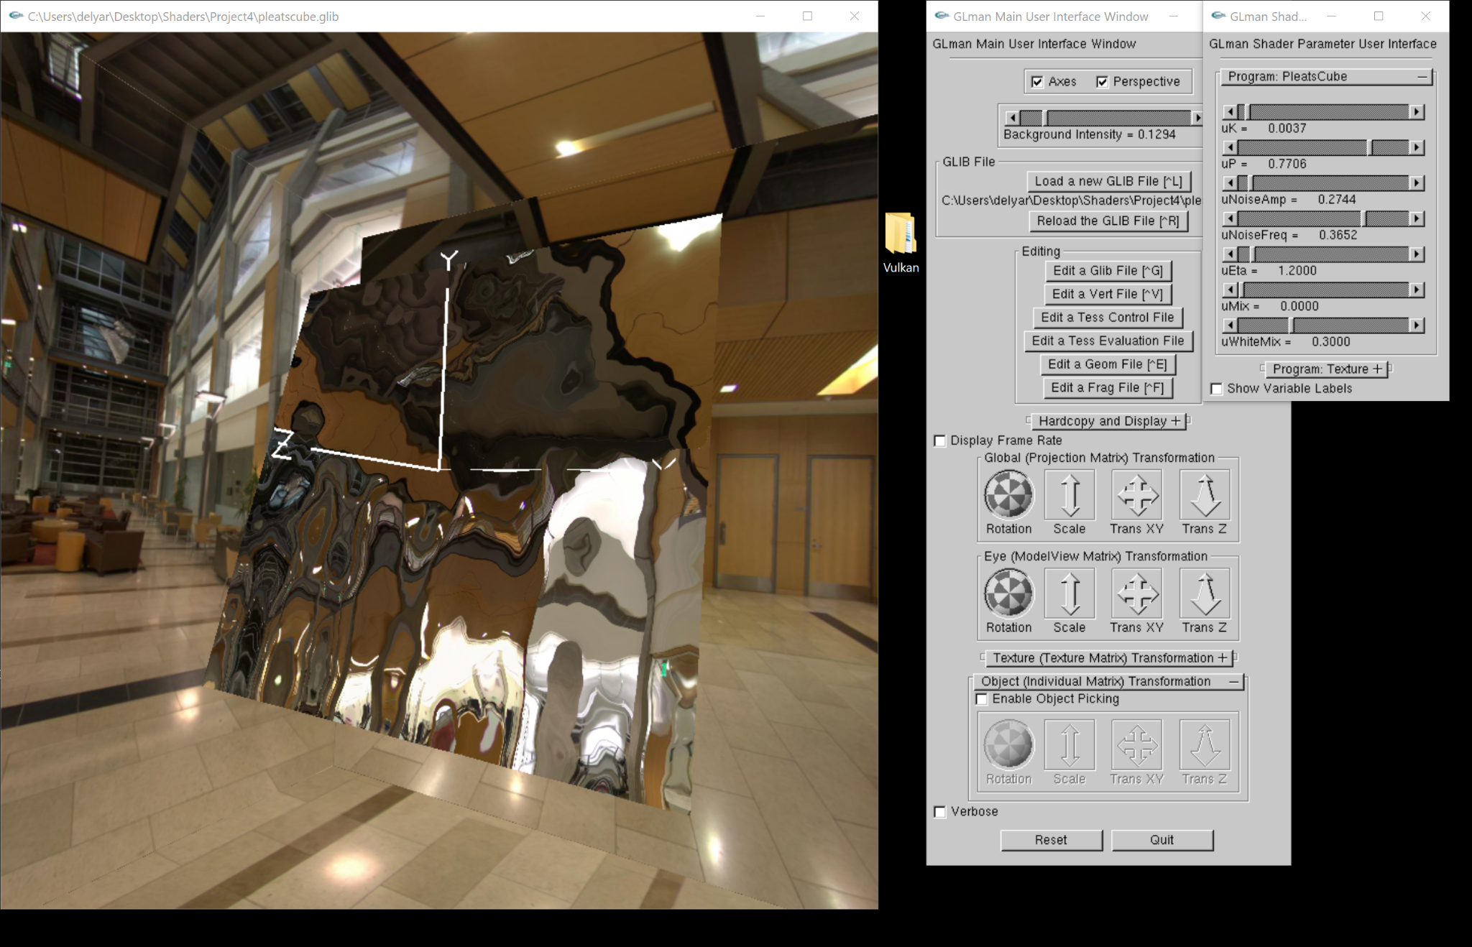

**Noiseamp = 5.0:**

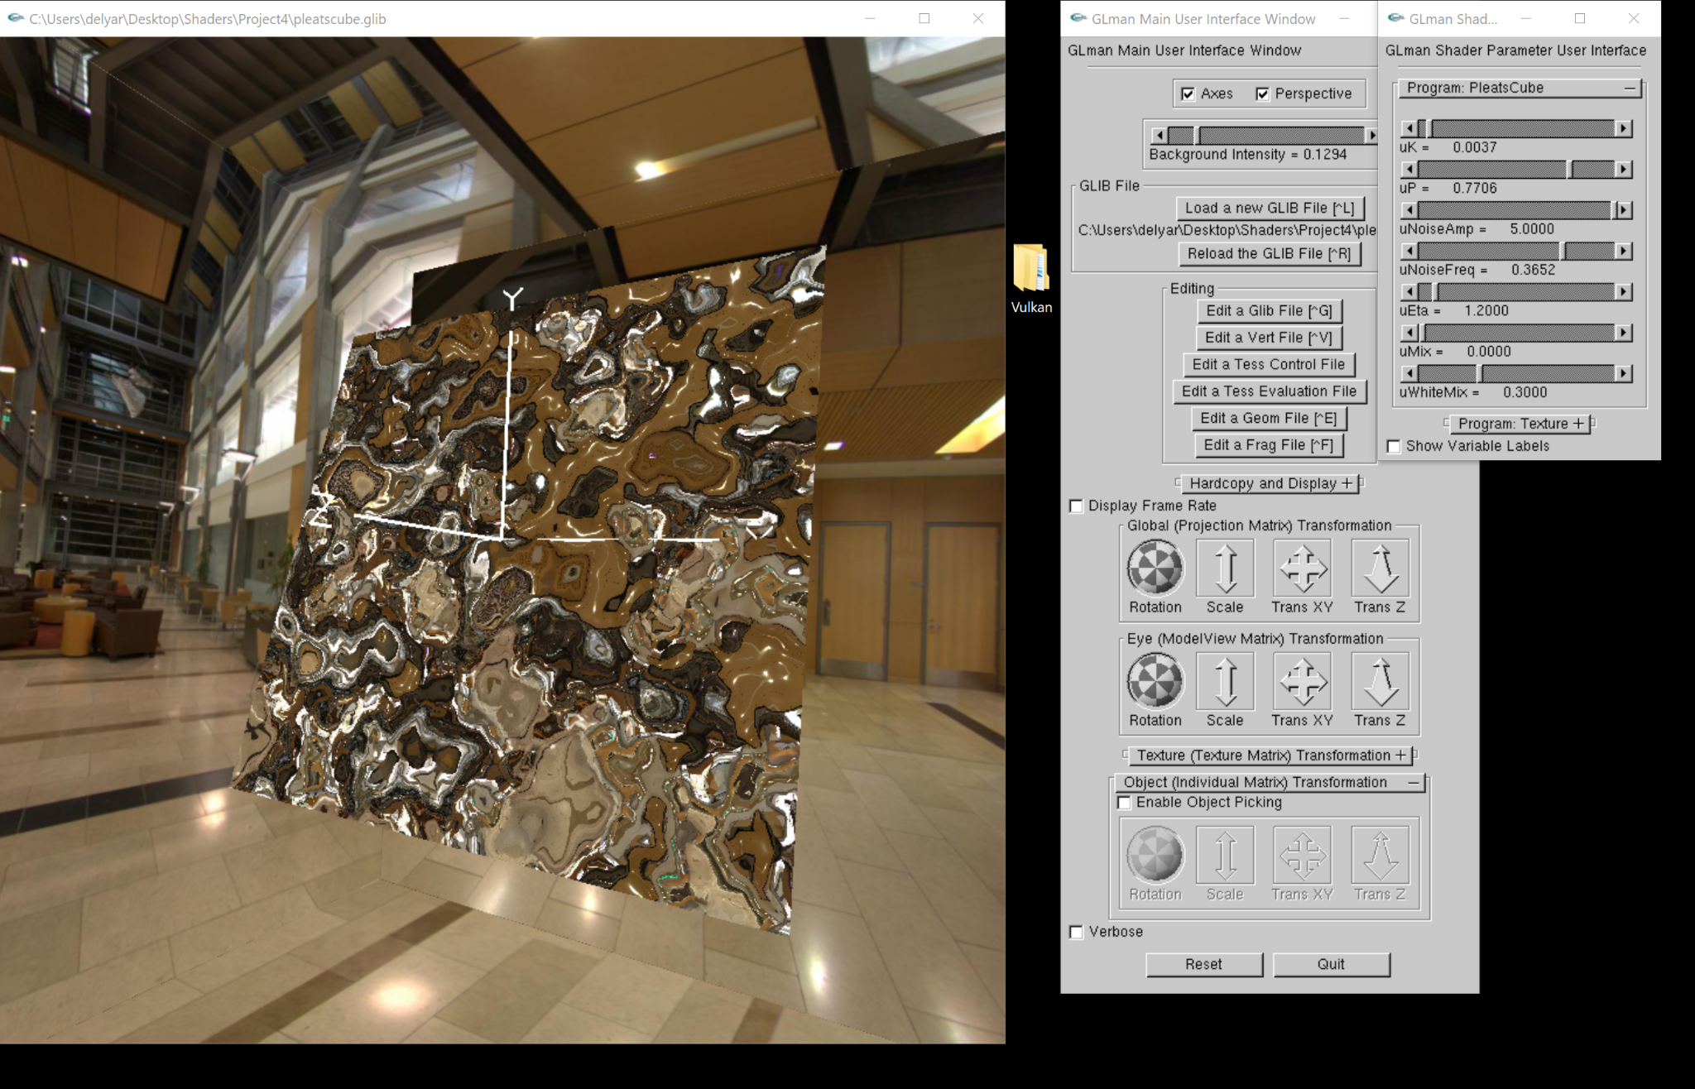

**Noise freq = 0.09**

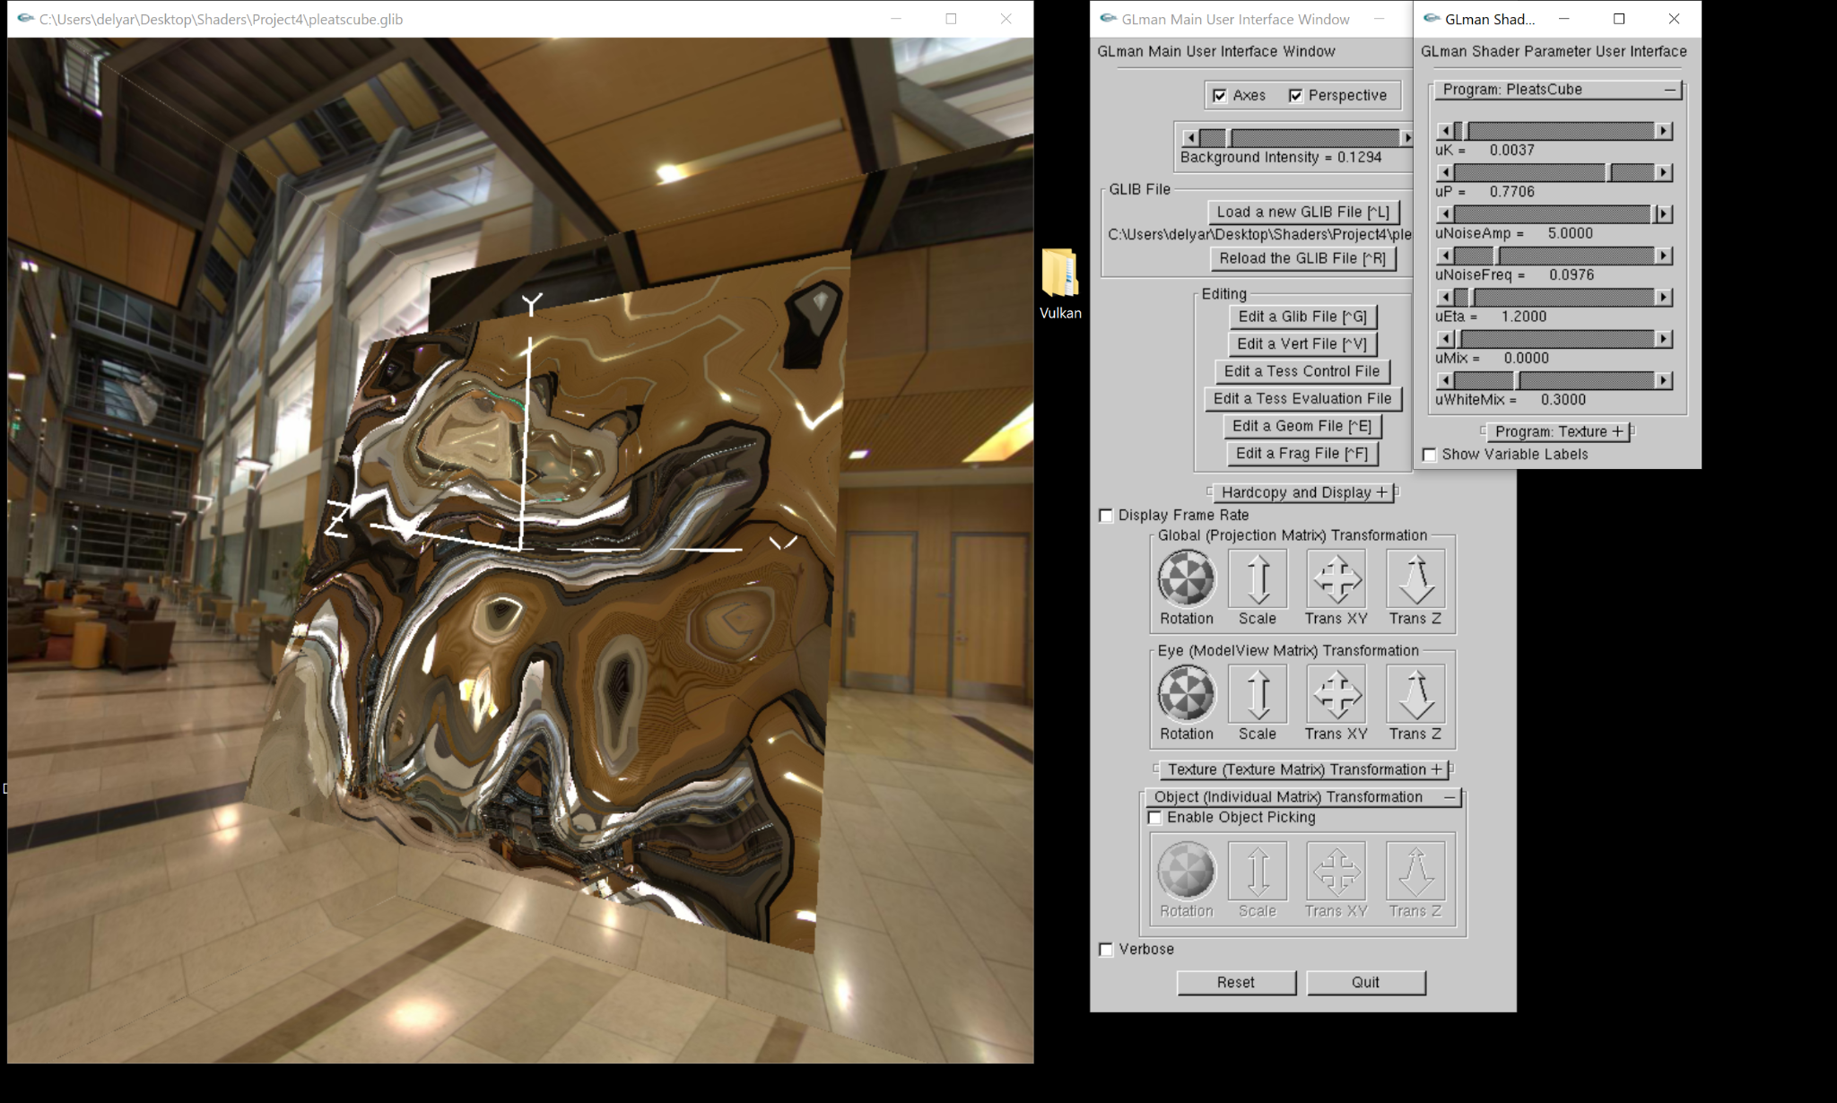

**Noise freq = 0.5**

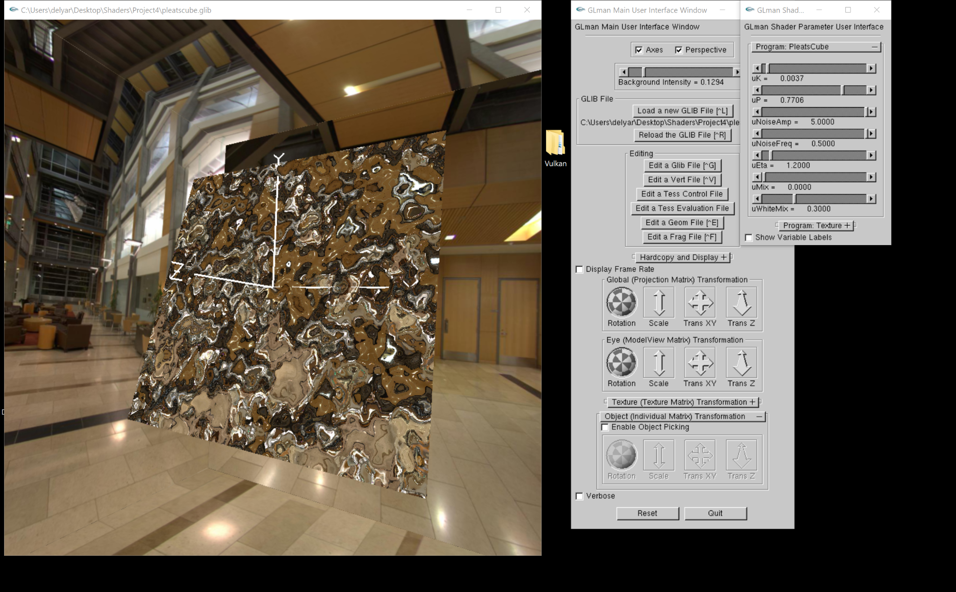

**Refraction:**

**uEa = 1.0, uMix = 0.9**

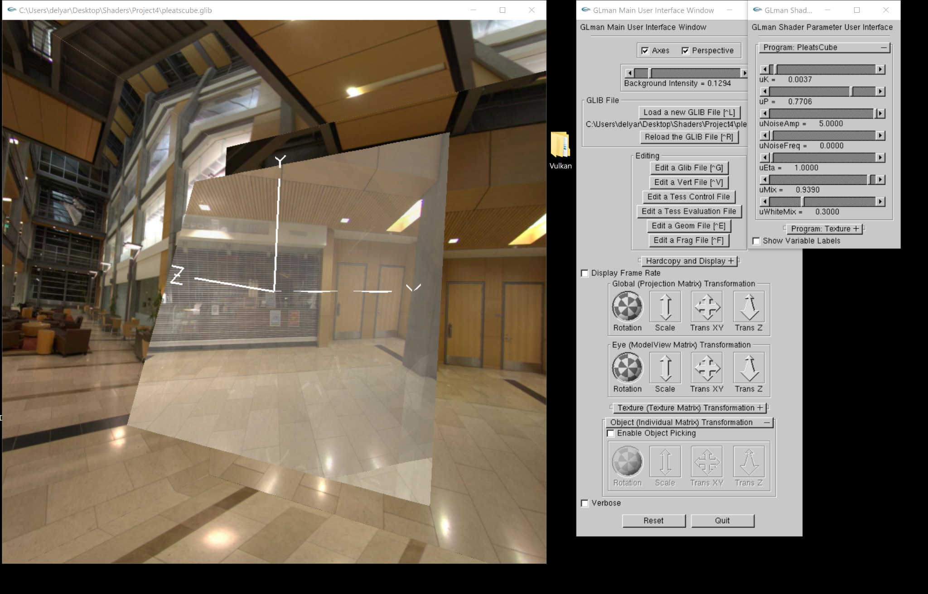

**uEa = 1.0, uMix = 0.31**

